**Lab 4**

**To Simplify Boolean Expressions and Implement Respective Digital Circuits Using Karnaugh Map**

**Note:** For examples, refer to the following link: <https://www.geeksforgeeks.org/introduction-of-k-map-karnaugh-map>

**Tasks**

1. **Construct K-Map for the function given below. Show the simplified output expression and verify the output with the help of software simulation.**

Z = f(A,B) = http://www.ee.surrey.ac.uk/Projects/Labview/minimisation/graphics/a.gifhttp://www.ee.surrey.ac.uk/Projects/Labview/minimisation/graphics/b.gif + A http://www.ee.surrey.ac.uk/Projects/Labview/minimisation/graphics/b.gif + http://www.ee.surrey.ac.uk/Projects/Labview/minimisation/graphics/a.gifB

K-Map

Simplified Output Function

Software Simulation of Logic Circuit From Simplified Function

(Show here your results for each combination that is present in the Boolean expression)

1. **Minimize the following function using K-Map. Verify the output expression with the help of simulation.**

f(a,b,c,d) = m(3,7,11,12,13,14,15)

K-Map

Simplified Output Function

Software Simulation of Logic Circuit From Simplified Function

(Show here your results for each combination that is present in the Boolean expression)

1. **Construct K-Map for the given POS form given below. Simulate your final expression (reduced) and show the results.**

F(A,B,C,D)=**π**(3,5,7,8,10,11,12,13)

K-Map

Simplified Output Function

Software Simulation of Logic Circuit From Simplified Function

(Show here your results for each combination that is present in the Boolean expression)

1. **Devise a minimized expression for the given truth table using K-Map (SOP form).**

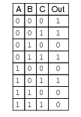

K-Map

Expression

Out=

1. **For the above truth table, devise an expression in POS form using KMap.**

K-Map

Expression

Out=

1. **Devise a truth table and Boolean expression for the given K-Map.**

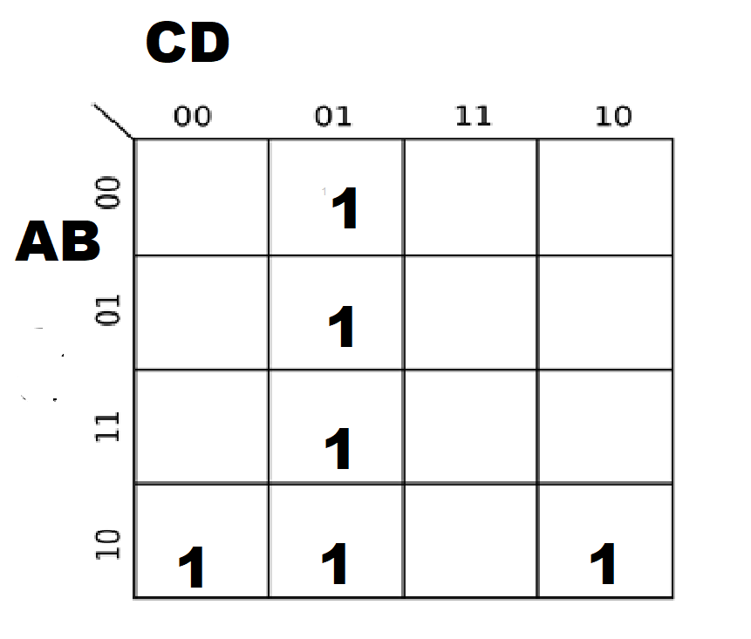

Truth Table

Expression